## Demo 3-01: Global Accelerator

This will teach us how to create a Global Accelerator when we have an EC2 instance as our endpoint.

1. Login to AWS Console and go to “Global Accelerator” under Network and Content Delivery.

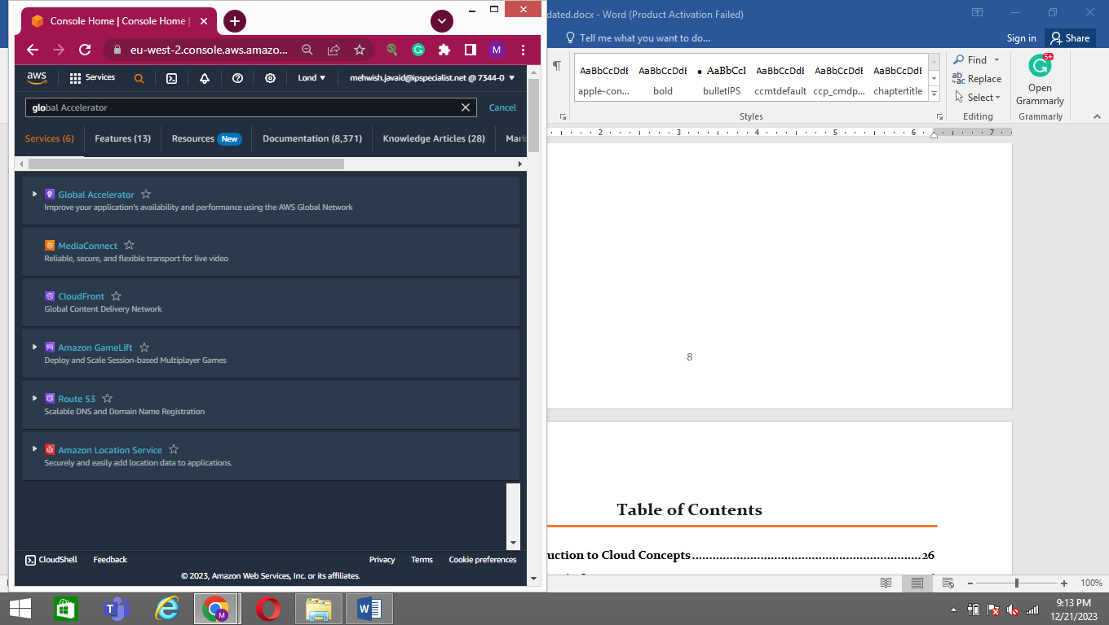

1. Click on “Create Accelerator”.

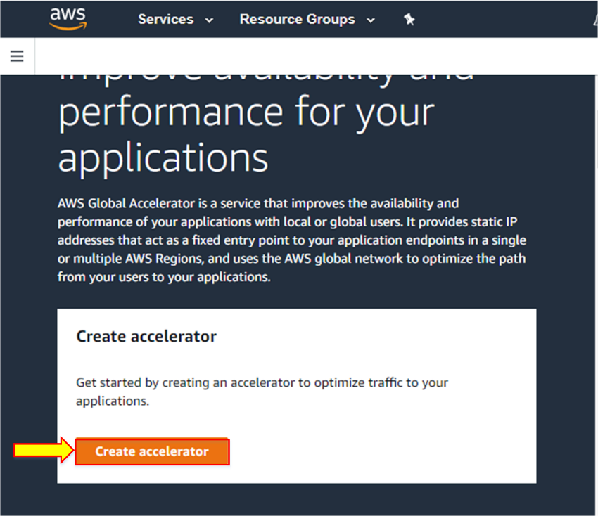

1. Enter the name or Accelerator and leave everything as default. Click “Next”.

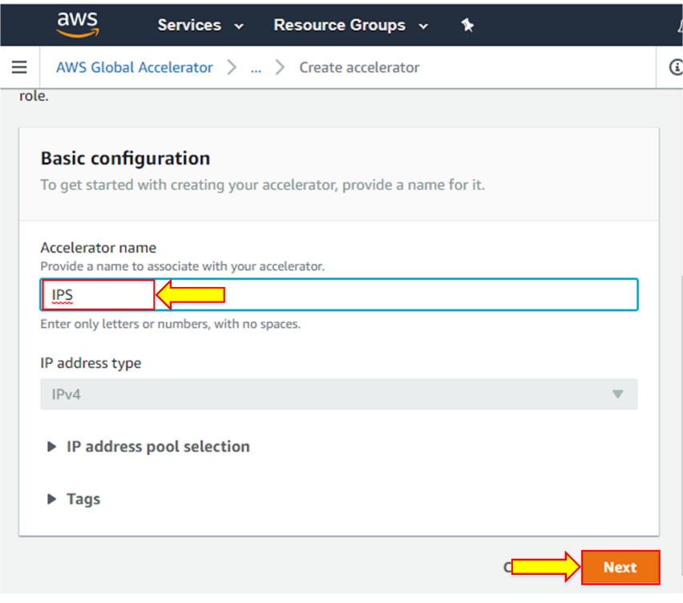

1. Now to configure the listeners, enter the port. Here we are using HTTP and HTTPS, so we write 80, 443. In protocol, we will select TCP. Leave the client affinity option and click “Next”.

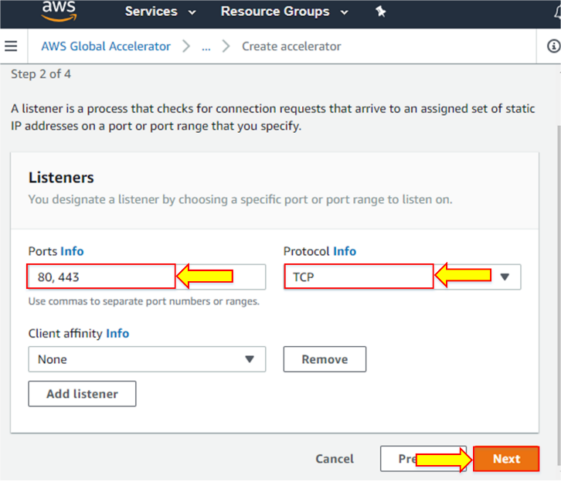

1. Now add endpoint groups, here, we select the region where we have our EC2 instance. Leave health checks configuration as default. Then click “Next”.

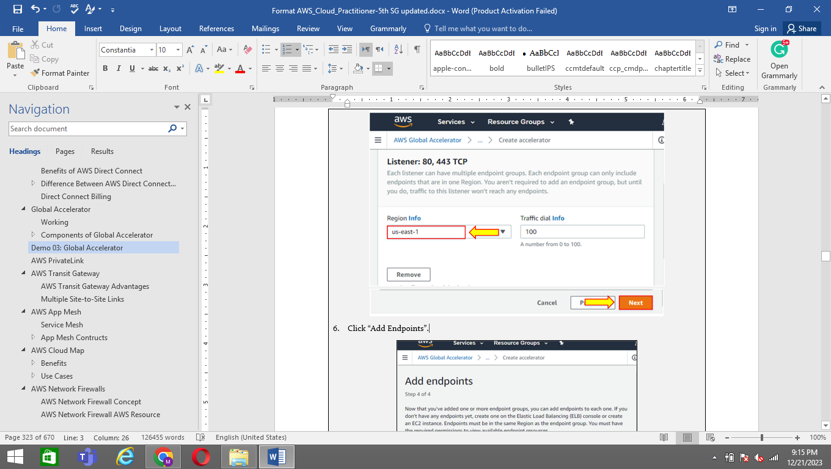

1. Click “Add Endpoints”.

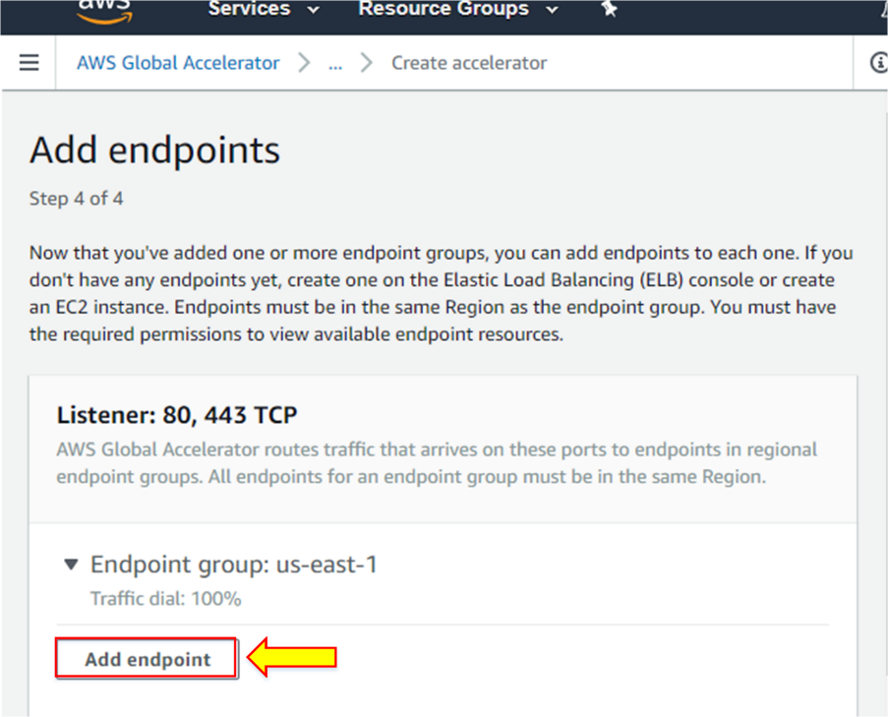

1. Select the endpoint type, which is the EC2 instance. Then in the endpoint, select the instance. Click “Create accelerator”.

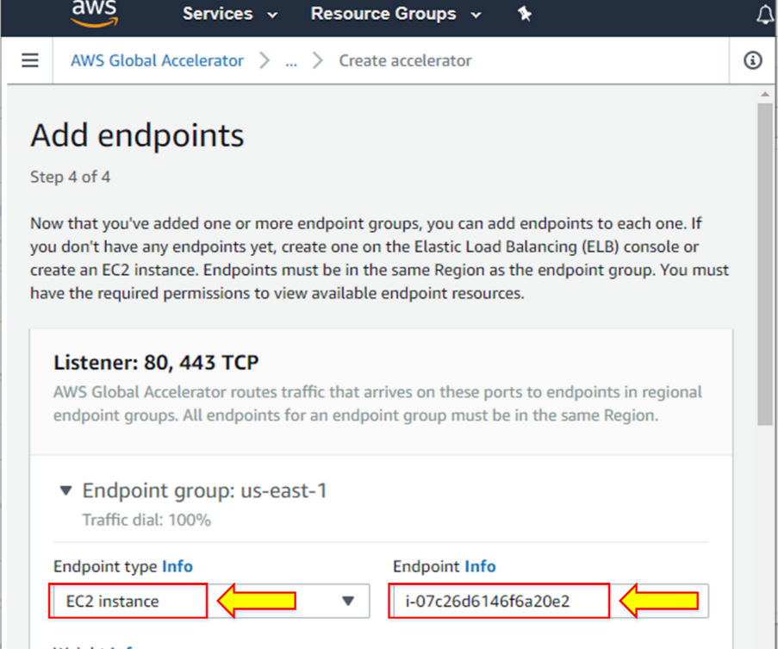

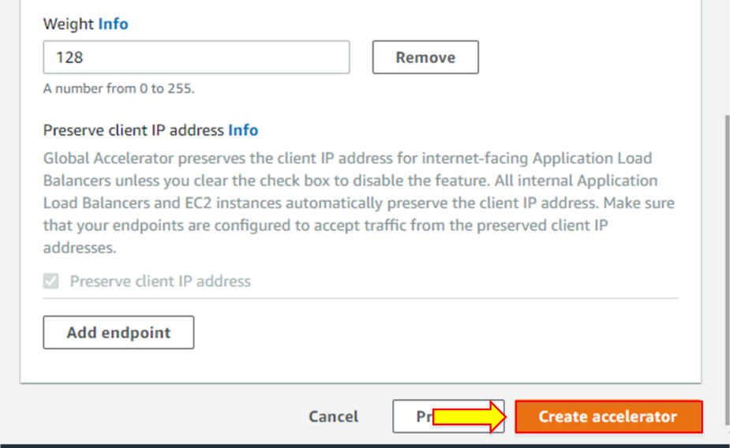

1. Your accelerator is now being created.

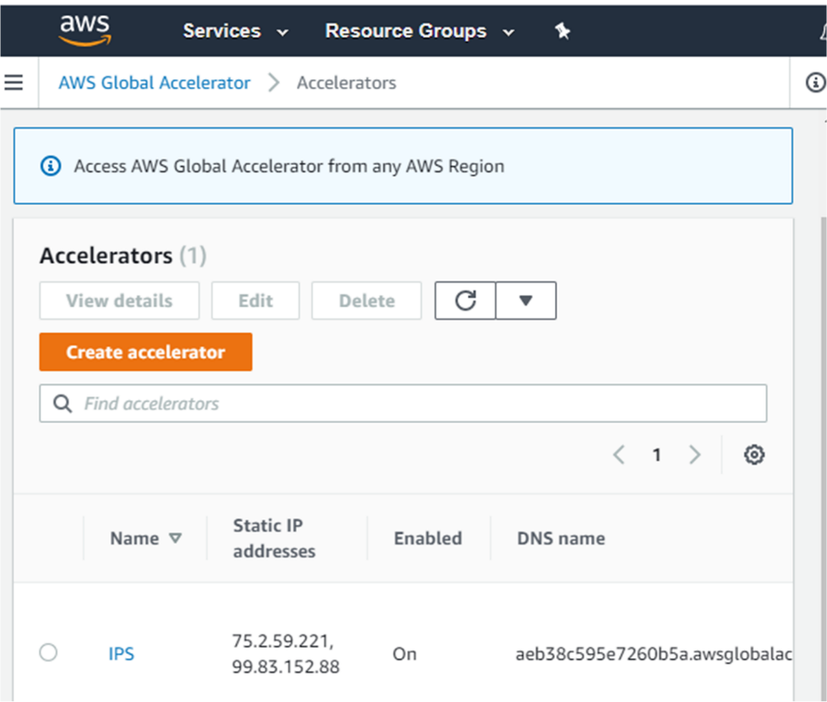

1. Once it is deployed, go to the accelerator, where you can make whatever changes you want to make in the configuration by using the edit option.

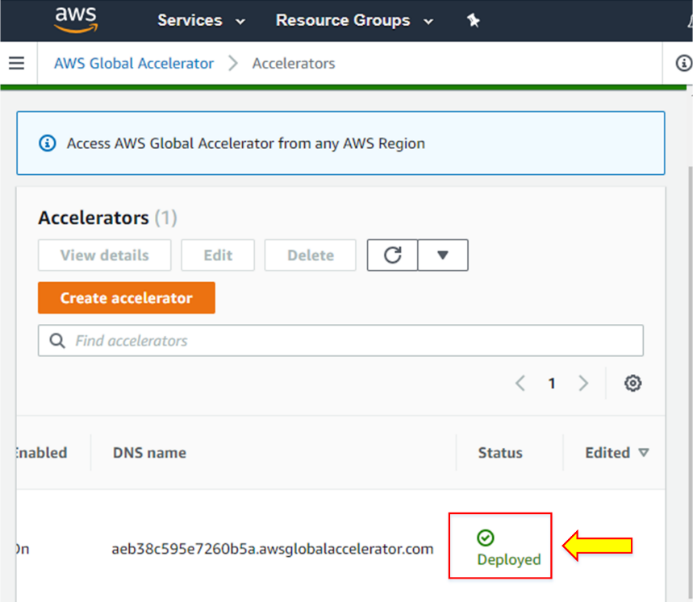

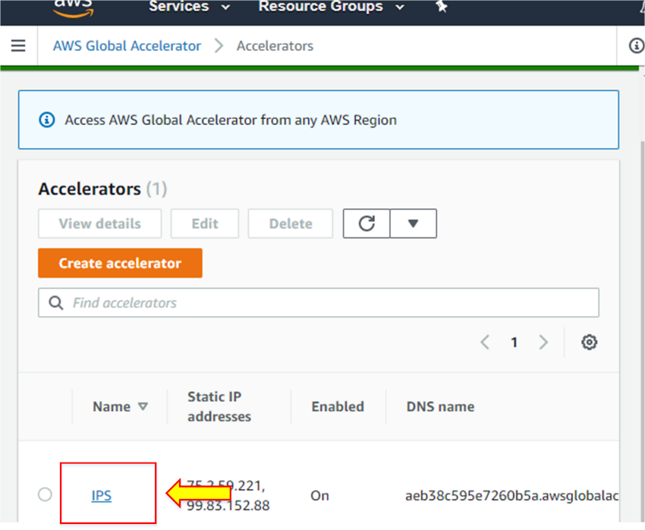

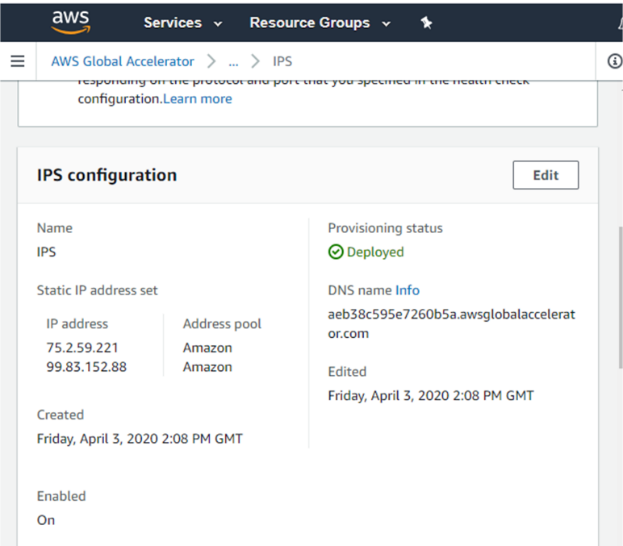

**Note:** When you need to delete the accelerator, first you need to disable it and then delete it.

## Lab 3-01: Create an S3 Bucket

### Service Introduction

Amazon S3 stands as the industry-leading object storage service, offering unparalleled scalability, security, and performance for diverse needs. Imagine a vast, ever-expanding warehouse where you can store anything - from images to application logs to petabyte-scale datasets - all accessible from anywhere with an internet connection.

### Problem

Let's consider you are a Web Developer and you are developing a social media web app like Facebook. All the profile pictures, videos, photos, and posts shared on social media web apps must be stored on a large database. Using an SQL database for storing web app files will be costly and will not provide backups. Furthermore, as it is not saved to the store, it can also be hacked easily. That’s why you need a reliable and scalable database to store data.

### Solution

For the above scenario, the solution is to use AWS S3 to store your large dataset as it provides backup and is reliable. AWS provides strong security and encryption policies on the data so that no one can hack your data. S3 is the most secure and scalable social media web application database.

**Follow the given steps to create an S3 bucket on the AWS Console.**

1. Log into the AWS Console.

2. Click on ‘Services.’

3. Select ‘S3’ from the ‘Storage’ list.



4. It is the same as IAM. The AWS S3 is also global, as you see in the right corner. You can select the region when you create an S3 bucket. Click on ‘Create Bucket’.



5. Enter the ‘DNS-Compliant’ bucket name. It must begin with a lowercase character or number and does not contain any uppercase letters. The length of the bucket name should be between 3 and 63 characters long and should not contain invalid characters such as exclamation marks.

6. Now, select the region where you want to deploy your bucket from the list of regions.



7. Scroll down and uncheck ‘Block Public Access’. We want to make objects public within our bucket and check on the ‘I acknowledge that current settings might result in this bucket and the objects within becoming public’.







8. Scroll down to 'Bucket Versioning,' which is set to 'disabled' by default.



9. Now scroll down; we have ‘Tags’ and ‘Default Encryption’, which set ‘Disable’ as default.



10. Click on the ‘Create Bucket’ button to proceed creation of the S3 Bucket.



11. Open the bucket by clicking on the bucket name ‘ips-practice-s3’ and start adding files.



12. Click ‘Create Folder’ to add a new folder to the bucket. Scroll down and set default ‘Disabled’ ‘Server-Side encryption’.







13. Click on the ‘Create Folder’ button to save the folder.





14. Add files to the bucket by clicking on the ‘Upload’ button.



15. Click ‘Add files’ and select files to upload.



16. After selecting the files, you can either click 'Upload' to directly upload them or scroll down to set permissions and properties for the files.

17. In the ‘Permissions’ section, you can manage users and their access permissions. You can also define whether you want to grant public access to the files.



18. In the ‘Properties’ section, you can select the storage class encryption type for the files and add the metadata and tags you want.



19. Review the details and click on the ‘Upload’ button to upload the selected files.





20. After the files are uploaded, you can still edit the properties and permissions of the files. To do this, click on ‘File Name’; it will navigate to its Overview tab.

21. In the properties tab, you will find ‘Object URL’. After clicking on it, you will be taken to the error page, where you will see Access Denied.





22. The reason for the error page is that you are trying to access a private file via URL, and you did not set Public Read Permissions for this file. For this, go back to the main bucket where the files are located.



23. To make it publicly accessible, select the file and then click on the drop-down ‘Actions’. Scroll down and click on ‘Make Public’. Now, your file is publicly accessible.





24. Another way to do this is by clicking on the file and going to the ‘Permissions’ tab.



25. After clicking on the Edit button, you will see ‘Everyone (Public Access)’. Click on ‘Read’ Objects.





26. Then, scroll down to check on ‘I understand the effects of these changes on this object’. After this, click on the ‘Save Changes’ button.







27. The properties tab in S3 Bucket provides you with different options such as Bucket Versioning, Static Website Hosting, Default Encryption, and Intelligent-Tiering Archive Configuration and Transfer Acceleration.



28. To get a quick overview of ‘Transfer Acceleration’, click on the ‘Edit’ button.



29. A window will open up, asking whether to enable or disable transfer acceleration. To see how transfer acceleration affects data transfers, copy the link "https://s3-accelerate-speedtest.s3-accelerate.amazonaws.com/en/accelerate-speed-comparsion.html" and paste it into your browser.



30. This speed checker simulates the transfer of a file from your browser to various AWS S3 regions with and without AWS S3 transfer acceleration. It compares the speed results and the percentage difference of every region.



31. The 'Permissions' tab provides access management options and the ability to create bucket policies.



32. The ‘Metrics’ tab provides Bucket metrics, storage class analysis, and replication metrics. Analyze and monitor storage.



33. The ‘Management’ tab provides options for lifecycle configuration inventory and replication cross-region replication. When configured, replicate the contents of one bucket to another. It can be used in the case of disaster recovery management.



34. The last tab of AWS s3 is the ‘Access Point’. The AWS S3 access point simplifies and manages data access at scale for shared datasets in AWS S3.



## Lab 3-02: Create A Website on Simple Storage Service S3

### Lab Prerequisites

* Familiarity with basic AWS Cloud Computing concepts and terminology
* An AWS account with an active subscription
* Take source code from: <https://github.com/12920/IPS-AWS-Cloud-Practitioner>

### Service Introduction

Amazon Simple Storage Service (Amazon S3) is an object storage service that uses a simple web service interface to store, access, and retrieve any type and amount of data over the internet. For user-generated content like photographs, movies, music, files, active archives, backup and recovery, and data lakes for Big Data analytics and data warehousing platforms, S3 delivers a secure, extremely durable, and scalable platform. It can also be used to build a serverless computing platform.

You can use Amazon S3 to host Static websites (such as .html). If the site receives many queries, static websites on S3 are ideal. WordPress, for example, cannot be hosted on S3 because it is dynamic and requires a database connection. All buckets are private by default, with no public read access; however, bucket policies can be used to make entire S3 buckets public. It allows you to use S3 to host a static website.

### Case Study Enterprise Retail – Primooz

Background

Primooz was established in the year 2010 by a group of investors in the United Kingdom. The company started selling high-quality foods, medicines, beverages, and fashion products in the United Kingdom. It has grown to become one of the most popular UK online shopping stores, gaining goodwill from shoppers due to its memorable in-store experience.

Primooz offices, manufacturing plants, data centers, and employees are based in the following locations:

* **Head Office in London:** Approximately 100 employees are based at the head office involving strategy, marketing, finance, human resources, technology, and operations
* **Regional Offices:** 3 Regional offices are in Manchester, Liverpool, and Leeds. Each office consists of 5 to 10 employees from Sales and Pre-Sales functions
* **Manufacturing Plants:** 2 Manufacturing plants are based in Liverpool and Shanghai, China
* **Datacentres:** Primooz has only one data center in London with 20 x 42U rack space
* **Remote Workforce:** Around 50 sales representatives are hired across the UK to boost sales

Business Challenge

Primooz development team is working on a new website to engage more customers on their platform. The website will post hundreds of food, health, and fashion blogs daily. The website will also encourage customers to review different products by uploading pictures and videos. Therefore, they will get special discount offers. The approximate launch time of the website will be three months. You are hired as a web developer for Primooz.

The business team is unsure about the amount of user traffic that the page will receive. They do not have spare hardware or time to prepare a full web server. For managing the high traffic of users in a day, developers need a powerful backend server to host these static websites. It will be hard for Web developers to manage everything because they can only do one thing at a time, either develop websites or manage servers. They need a durable hosting service to manage their static websites.

Proposed Solution

As a Web Developer, you have decided to use AWS S3 static website hosting resources to host a static website. By using S3 hosting, it will free developers to manage servers. It will reduce the costs and time of a developer as it will only focus on website development rather than taking the workloads of managing servers. This type of static website is known as a serverless website. Developers use third-party servers or cloud providers rather than building or using their servers.

Lab Diagram

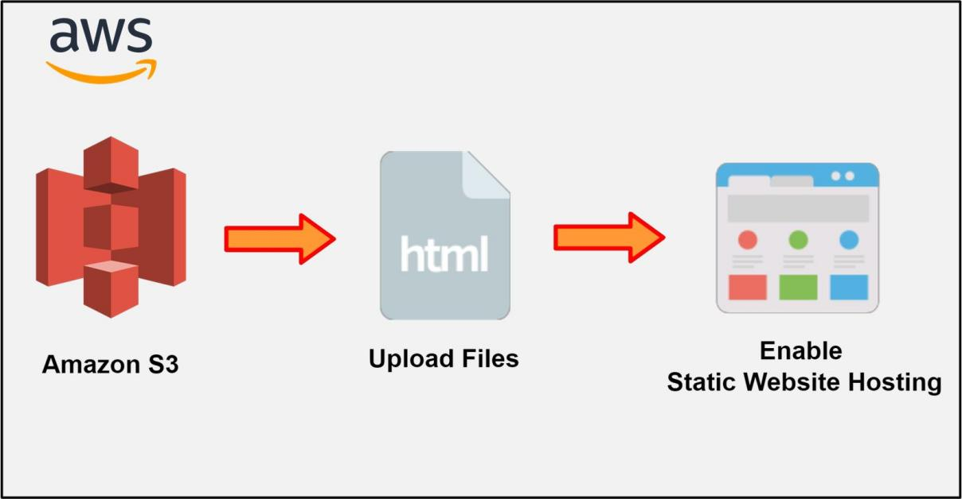

Figure 3-04: Host a website using S3

Implementation Steps

1. Create an S3 Bucket.
2. Upload files in the S3 Bucket.
3. Files to Make Public.
4. Enable Static website hosting.

### Solution

|  |
| --- |
| **Step 1: Create an S3 Bucket**   1. Log in to the **AWS Console**. 2. Click on **Services**.      1. Select **S3** from the storage list.      1. Click on the **Create Bucket** button to host a **static website**.      1. After entering the **DNS unique name,** select the **region**. 2. Enter **aws-retailer-website** as **Bucket name** and Select **US East (N. Virginia)** as **AWS Region**.      1. Now, uncheck **Block *all* public access**. 2. Select **Create bucket**.      1. You will see the **aws-retailer-website bucket** has been **successfully created**.     **Step 2: Upload Files in the S3 Bucket**   1. Once a bucket is created, you will need to **upload .html files** and other related website content onto it. 2. Click on the newly created **aws-retailer-website bucket** to **upload files**. 3. Click on **Upload**.      1. Here, you upload **Index.html** and **Error.html** files for your website's landing and error page, respectively. **OnlineRetailerShop.jpg** is an image file that you will be using on your website. 2. After uploading files, click on **Upload**.      1. When you navigate to the **Index.html**, you will show an **error message** as below:      1. It is because you are not changing the file's permission to **Public**.   **Step 3: Files to Make Public**   1. You can select the **Index.html** file, then go to **Actions** to make it public by clicking **Make public via ACL**.      1. Now, click on **Make public**.      1. It has now been made **public,** as the green note states above. 2. Click on the **Close** button.      1. After that, click on **Index.html** and then on **URL**. You will be able to see the **website**.      1. To make the whole bucket public, go to the **Permissions** tab. 2. Then, go to **Bucket policy** and click on the **Edit** button.      1. Copy-paste this **.json code** in the **Bucket policy** text area and click **Save changes**. 2. Make sure line 13 of the code contains your bucket name.      1. Once you click on **Save**, you will see in red on your bucket that it is **Publicly accessible**. The above code grants public access to your bucket.     **Step 4: Enable Static Website Hosting**   1. Now, go to the **Properties** tab and, at the bottom, select **static website hosting**. Then click on **Edit**.      1. Select **Enable** option for static website hosting. 2. Enter index and error document file names, which in your case are **Index.html** and **Error.html**. 3. Click on the **Save changes** button.      1. After this, click on the **Endpoint** link given at the **static website hosting**, and copy and paste it into your browser to open your website. |

## Lab 3-03: Create A Website on S3 by Enabling Versioning

### Lab Prerequisites

* Familiarity with basic AWS Cloud Computing concepts and terminology
* An AWS account with an active subscription

### Service Introduction

Amazon Simple Storage Service (Amazon S3) is an object storage service that uses a simple web service interface to store, access, and retrieve any type and amount of data over the internet. For user-generated content like photographs, movies, music, files, active archives, backup and recovery, and data lakes for Big Data analytics and data warehousing platforms, S3 delivers a secure, extremely durable, and scalable platform. It can also be used to build a serverless computing platform.

You can use Amazon S3 to host Static websites (such as .html). If the site receives many queries, static websites on S3 are ideal. WordPress, for example, cannot be hosted on S3 because it is dynamic and requires a database connection. All buckets are private by default, with no public read access; however, bucket policies can be used to make entire S3 buckets public. It allows you to use S3 to host a static website.

Amazon S3 offers versioning as well as protection. Every version of each object saved in your Amazon S3 bucket may be preserved, retrieved, and restored using versioning. With this backup technique, you can quickly recover from unexpected user actions and application faults.

### Case Study Enterprise Retail – Primooz

Background

Primooz was established in the year 2010 by a group of investors in the United Kingdom. The company started selling high-quality foods, medicines, beverages, and fashion products in the United Kingdom. It has grown to become one of the most popular UK online shopping stores, gaining goodwill from shoppers due to its memorable in-store experience.

Primooz offices, manufacturing plants, data centers, and employees are based in the following locations:

* **Head Office in London:** Approximately 100 employees are based at the head office involving strategy, marketing, finance, human resources, technology, and operations
* **Regional Offices:** 3 Regional offices are in Manchester, Liverpool, and Leeds. Each office consists of 5 to 10 employees from Sales and Pre-Sales functions
* **Manufacturing Plants:** 2 Manufacturing plants are based in Liverpool and Shanghai, China
* **Datacentres:** Primooz has only one data center in London with 20 x 42U rack space
* **Remote Workforce:** Around 50 sales representatives are hired across the UK to boost sales

Business Challenge

Primooz web developers are working on an e-commerce website, creating a new version deployed on the server. After the deployment, you will be required to check if there are any bugs on the new version of the website. You want to roll back to the previous version of the website as soon as possible because the new version has bugs, and it will take a long time to fix all of them, creating inconveniences for the users. So, how will you manage or track the new and old versions of websites?

***Proposed Solution***

Primooz web developers use the S3 version to track the new and old versions of the e-commerce website. As you host your old version of the website on S3 and deploy the new version by enabling S3 versioning, your old and new versions of the website will be tracked. If the new version contains bugs, the S3 version retains the older version with a single click, allowing you to easily revert to an earlier version of the website.

Lab Diagram

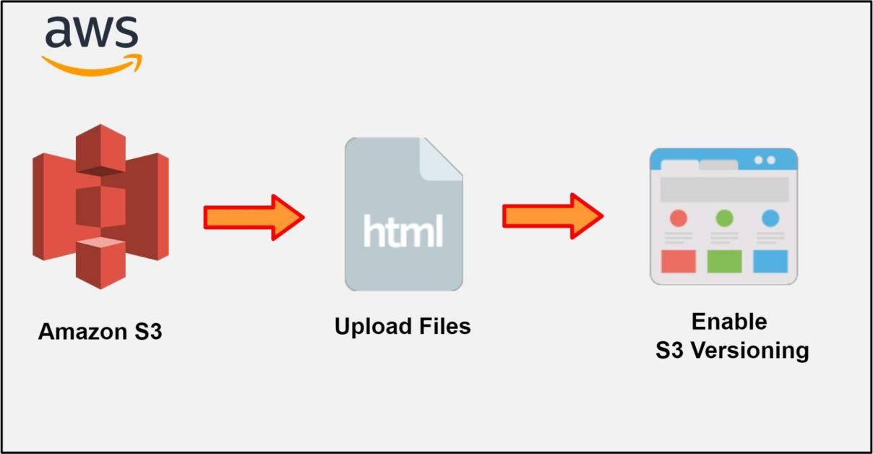

Figure 3-05: Enable Versioning Concept

Implementation Steps

1. Enable S3 versioning.
2. Upload a new version of the Website.
3. Roll back the old version of the Website.

### Solution

|  |
| --- |
| **Step 1: Enable S3 Versioning**   1. Log in to the **AWS Console**. 2. Click on **Services**.      1. Select **S3** from the **Storage** list.      1. Then click on the bucket where you last deployed your **static website**. 2. Now, click on **Properties** and go to **Object Versioning**. Go ahead and click on the **Edit** button.      1. Click on **Enable**.   ***Note:*** This allows you to keep multiple variants of an object in the same bucket. Versioning allows you to save, retrieve, and restore different bucket versions.   1. Now, go ahead and click on the **Save Changes** button.     **Step 2: Upload a New Version of the Website**   1. Now, click on the **Objects** tab. 2. You can see that there is a little tab saying **Show Versions**. So, click on this tab. Now, you have only one version of **Index.html**.      1. Now **upload** the **new version of a file**. 2. Click on the **Upload** button.      1. After successfully uploading, you will be able to see that you have **two different versions**. You can see the timestamp here, and then you have the newest version of **Index.html**.      1. Go ahead and click on the new **Index.html** URL.      1. After clicking on the **URL**, you will be able to see **Version two of the Website**.     **Step 3: Roll Back the Old Version of the Website**   1. Now, go back to the bucket and look at your versions. We will try to **roll** this version back. 2. Now, delete the object and upload **Index.html version two**. 3. Select the newly uploaded **Index.html** and then click on the **Delete** button.      1. You will be asked if you want to delete objects permanently. Type **permanently delete** and then click the **Delete Objects** button.      1. Now, return to our objects, where you will see that there is only **one version** of the **Index.html** object.      1. If you click on **Index.html** and go to the **URL**, we see that we have lost version two. |

## Lab 3-04: Create and Activate an Amazon S3 File Gateway

### Service Introduction

Creating and activating an Amazon S3 File Gateway involves accessing the AWS Management Console, navigating to the Storage Gateway service, and selecting the option to create a File Gateway. Upon configuration, including naming, region selection, and VPC setup, an activation key is generated. This key is crucial for activating the gateway software, which needs to be installed on a local machine. After pasting the activation key into the software, the on-screen instructions guide users through the activation process. Once completed, the gateway status in the AWS Management Console changes to "Activated," allowing users to configure file shares by associating them with specific S3 buckets and setting up necessary access permissions. This enables seamless management and access to files via the File Gateway, serving as a bridge between the local environment and Amazon S3 storage.

### Problem

An organization has multiple applications running on-premises and on cloud platforms. The Data Engineer has been assigned to implement such a solution that will store application data files and backup images in secure cloud storage using AWS. Which option will the Data Engineer use to fulfill the mentioned requirement?

### Solution

Data Engineer can implement Amazon S3 File Gateway, which provides a seamless way to connect to the Cloud and store app data.

|  |
| --- |
| **Step 01: Set up an Amazon S3 File Gateway.**  1. Log in to AWS Management Console using your credentials.    2. From the search bar, search and open **Storage Gateway.**    3. Click on **Create Gateway.**    4. The **Set up Gateway** page will appear.    6. The local time zone for the region of the world where you want to deploy your gateway should be selected as the **Gateway time zone.**  5. Scroll down, and select **Amazon S3 File Gateway** as a Gateway option.    6. In the **Platform options**, select the platform of your choice.    7. For **Set up Gateway**, follow the given steps to launch the **EC2 instance.**  8. Navigate to **Amazon EC2 console** and click on **Launch instance.**  9. For **Instance type**, select the size of an instance of your own choice.  10. For **Networking settings,** select the VPC that you want your EC2 instance to run in.  11. For **Subnet**, specify the subnet that your EC2 instance should be launched in.  12. For **Auto-assign Public IP**, select **Enable.**  13. For **Inbound security group rules**, add firewall rules to allow clients to connect to your instance.  **Note:** Amazon S3 File Gateway required TCP port 80 to be open for inbound traffic and one-time HTTP access during gateway activation. After activation, you can close this port.  14. After launching an instance, verify the status of the instance and save the instance ID and IP address.    15. Go back to the storage gateway page. After the **Platform Options,** **Confirm set up gateway** and click on **Next.**    **Step 02: Connect your Amazon S3 File Gateway to AWS**  16. For the **Endpoint options**, click the **Publicly accessible** option as a **Service endpoint.**    **Note:** Your gateway uses the open internet to communicate with AWS. If you choose this choice, you must specify whether the connection must adhere to Federal Information Processing Standards by checking the FIPS enabled endpoint box (FIPS).  17. Select the **IP address** option under **Connection options** in the **Gateway connection settings** section. Then, go to the recently created EC2 instance and copy the IP address.    18. In the Storage Gateway page, paste the **IP address** and click on **Next.**    **Step 03: Activate Amazon S3 File Gateway.**  19. After that, setup **S3 File Gateway.** From the **Storage Gateway page**, click on **File share** from the left side given menu.  20. Click on **Create File share.**    21. Select the **S3 bucket name** as **Amazon S3 Location.**  22. Then, write the bucket name.    23. Choose **NFS** for access objects and **None** for Automated cache refresh from S3.    24. Add tags if you want, then click on **Next.**    25. This will launch the AWS Storage Gateway console's **Configure gateway** page.  26. Use the dropdown menus in the **Configure storage** section to assign at least one local disk with a minimum capacity of 150 gibibytes (GiB) to **Cache.** The physical storage that you set up on your host platform is represented by the local disks indicated in this section.  27. Choose how to set up Amazon CloudWatch Logs to check on the health of your gateway in the **CloudWatch log group** section.  28. Choose how to set up Amazon CloudWatch alerts in the **CloudWatch alarms** section to receive notifications when the metrics for your gateway depart from predetermined boundaries.  29. Add tags if you want and click on **Configure** to complete the configuration process. |

## Lab 3-05: Building a Web Server

### Lab Prerequisites

* Familiarity with basic AWS Cloud Computing concepts and terminology
* An AWS account with an active subscription

### Service Introduction

Amazon Elastic Compute Cloud (Amazon EC2) is a web service that offers safe and scalable cloud-based compute capability in the form of EC2 instances. It was launched in 2006, and these are cloud-based virtual servers. With Amazon EC2, any developer may take advantage of Amazon's compute capacity to satisfy their business needs with no upfront costs and no performance tradeoffs. Amazon EC2 is a full virtual computing environment with web service interfaces for launching instances with various operating systems, loading bespoke application environments, managing network access rights, and running images. Amazon EC2 allows you to use as many or as few systems as you want.

Amazon EC2 provides the tools needed to create fault-tolerant applications that can withstand common failures. When building a system, it is good to presume that something will go wrong. You will always develop, implement, and deploy systems with an automatic recovery and restoration plan if you do it this way. With Amazon EC2, you may supply numerous instances at once, ensuring the system continues functioning even if one instance fails.

### Case Study Enterprise Retail – Primooz

Background

Primooz was established in the year 2010 by a group of investors in the United Kingdom. The company started selling high-quality foods, medicines, beverages, and fashion products in the United Kingdom. It has grown to become one of the most popular UK online shopping stores, gaining goodwill from shoppers due to its memorable in-store experience.

Primooz offices, manufacturing plants, data centers, and employees are based in the following locations:

* **Head Office in London:** Approximately 100 employees are based at the head office involving strategy, marketing, finance, human resources, technology, and operations
* **Regional Offices:** 3 Regional offices are in Manchester, Liverpool, and Leeds. Each office consists of 5 to 10 employees from Sales and Pre-Sales functions
* **Manufacturing Plants:** 2 Manufacturing plants are based in Liverpool and Shanghai, China
* **Data centers:** Primooz has only one data center in London with 20 x 42U rack space
* **Remote Workforce:** Around 50 sales representatives are hired across the UK to boost sales

***Business Challenge***

You are working as a web developer in Primooz. You develop a website and deploy it on a cloud server. Primooz is currently facing serious challenges in scaling a few high-demand applications in its on-premises data center. The infrastructure is under stress during the Christmas and new year periods, and every year there is a requirement to add more resources to cope with customer demand. The management has directed the CTO to explore a public cloud option.

Proposed Solution

As the web developer for an AWS partner, you have been asked to deploy Linux-based web servers for the Primooz development team. The servers should install Apache software to initiate the Proof of Concept (PoC). The development team is currently based in Manchester and will require access to the server over the internet.

Lab Diagram

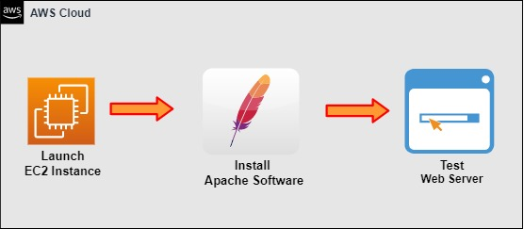

Figure 3-07: Build a Web Server

Implementation Steps

1. Launch an EC2 Instance.
2. Install Apache Software.
3. Test the Web Server.

### Solution

|  |
| --- |
| **Step 1: Launch an EC2 Instance**   1. Log in to the **AWS Console.** 2. Click **Services**.      1. Select **EC2** from **Compute**.      1. On the left-hand menu, click **Instances.**      1. Click **Launch instances**.      1. In **Step 1: Choose an Amazon Machine Image**, locate **Amazon Linux 2 AMI (HVM), SSD Volume Type**, check **64-bit (x86)**, and click **Select**.      1. In **Step 2: Choose an Instance Type**, select **t2.micro**, and click **Next: Configure Instance Details**.     **Note:** The t2.micro is a free tier eligible option.   1. Leave everything by **default**, and go to **Step 5: Add Tags**.   **Key** **Value**  Name Web server01  Department Development Team   1. Click on **Next: Configure Security Group**.      1. In **Step 6: Configure Security Group**, select **Create a new security group**. 2. Set **Security group name** as **WebDMZ**. 3. Set the **Description** as **WebDMZ**. 4. Select **Add Rule**.   Type: **HTTP**  Protocol: **TCP**  Port Range: **80**  Source: Custom, **0.0.0.0**   1. Click **Review and Launch**.      1. Click **Launch**.      1. In the key pair dialog pop-up, select **Create a new key pair**. 2. Set the **Key pair name** as **WebPrivateKey**. 3. Click on the **Download** button.      1. Click **Launch Instances**.      1. Click **View Instances**.     **Step 2: Install Apache Software**  Apache is a web server responsible for receiving directory (HTTP) requests from internet users and responding with the files and Web pages they requested.   1. Select **Running Instances.** 2. Copy the **public IP address** of the **EC2 instance** to log in through the AWS command line.      1. Open **PuTTYgen** to convert the **.pem** file into **.ppk** file and save the private key. 2. Once you are done, close **PuTTYgen** and open **PuTTY**. 3. Navigate to **SSH** and then **Auth** from the left side of the Category pane. 4. Select the key private key and click **Open**. 5. Enter the **public IP address** of the EC2 instance **Host Name (or IP address)** and **Saved Sessions fields**. Click the **Save** button, and click **Open**.      1. The **PuTTy Security Alert** window will **open**. Click on **Accept** to proceed further.      1. It may prompt you for a username, so type in **ec2-user** and hit enter. You will be logged in to your **Public Instance**. 2. Type in **sudo su** to get super-user access and **clear** the screen.      1. Type yum install httpd -y to install **Apache software** in the EC2 instance.      1. Once **Apache** is installed, you need to start the **Apache server**. 2. Type in service httpd start to start the **Apache server**.      1. Type **cd /var/www/html** to type in the landing page. 2. Run the **ls** command, and you will see that it is currently empty. 3. Once again, **clear** the screen.      1. Type **nano index.html** to open the html editor. 2. Then type **ls**.      1. Edit the landing page of your website as you want. 2. Then click **Yes** to save the text.      1. Close the editor, and you will see that the **index.html** is saved.     **Step 3: Test the Web Server**   1. Open up your **browser** and test your **website**. 2. Enter the **public IP address** in the browser, and you should be able to see your webpage **index.html**. |

## Lab 3-06: Managing AWS IAM User Permissions using Groups and Policies

### Lab Prerequisites

* Familiarity with basic AWS Cloud Computing concepts and terminology
* An AWS account with an active subscription

### Service Introduction

AWS Identity and Access Management (IAM) is a web service that gives you safe control over AWS resources like computing, storage, databases, and application services. IAM controls who is logged in and whether they have permission to use resources by managing authentication and authorization. IAM uses access control concepts such as Users, Groups, Roles, and Policies to control which users can access specific services, the types of actions they can perform and which resources are available. The IAM service is free from any additional charge. However, your account will be charged depending on your users' usage of other AWS services.

A Group is a collection of IAM users. You can use groups to specify permissions for a collection of users, making it easier to manage their permissions. An IAM policy is a rule (or group of rules) defining which AWS resource operations are authorized or refused. Policies are used to grant permissions, and a policy determines the permissions of identity or resource when attached to it. When a user makes a request, AWS examines these policies. The policies' permissions govern whether the request should be granted or denied. AWS stores policies as JSON documents that are either identity-based or resource-based.

### Case Study Enterprise Retail – Primooz

Background

Primooz was established in the year 2010 by group of investors in the United Kingdom. The company started selling high-quality foods, medicines, beverages, and fashion products in the United Kingdom. Now, it has grown to become one of the most popular UK online shopping stores, gaining goodwill from shoppers due to its memorable in-store experience.

Primooz offices, manufacturing plants, data centers, and employees are based in the following locations:

* **Head Office in London:** Approximately 100 employees are based at the head office involving strategy, marketing, finance, human resources, technology, and operations
* **Regional Offices:** 3 Regional offices in Manchester, Liverpool, and Leeds. Each office consists of 5 to 10 employees from Sales and Pre-Sales functions
* **Manufacturing Plants:** 2 Manufacturing plants based in Liverpool and Shanghai, China
* **Datacentres:** Primooz has only one data center in London with 20 x 42U rack space
* **Remote Workforce:** Around 50 sales representatives are hired across the UK to boost sales

#### Business Challenge

Until the early 2020s, Primooz was facilitating its customers properly. When the COVID-19 pandemic surfaced, people were locked in their homes, and the trend of online shopping increased. The data center is under pressure as its current operational capability is not meeting the required challenge. The founder, Leo, needs help setting up his development team with the proper access permissions. The management has decided to add more resources with full access permissions to cope with customer demands. For this, management has directed a CSE to explore the solution of the public Cloud.

#### Proposed Solution

As a Cloud Security Engineer, you have decided to use AWS Identity & Access Management (IAM) to deal with the current challenge. In order to provide access and ensure the proper security measures are in place, you will use AWS Identity & Access Management (IAM). You will add users, group users, and assign permissions for the developer group using policies.

#### Lab Diagram

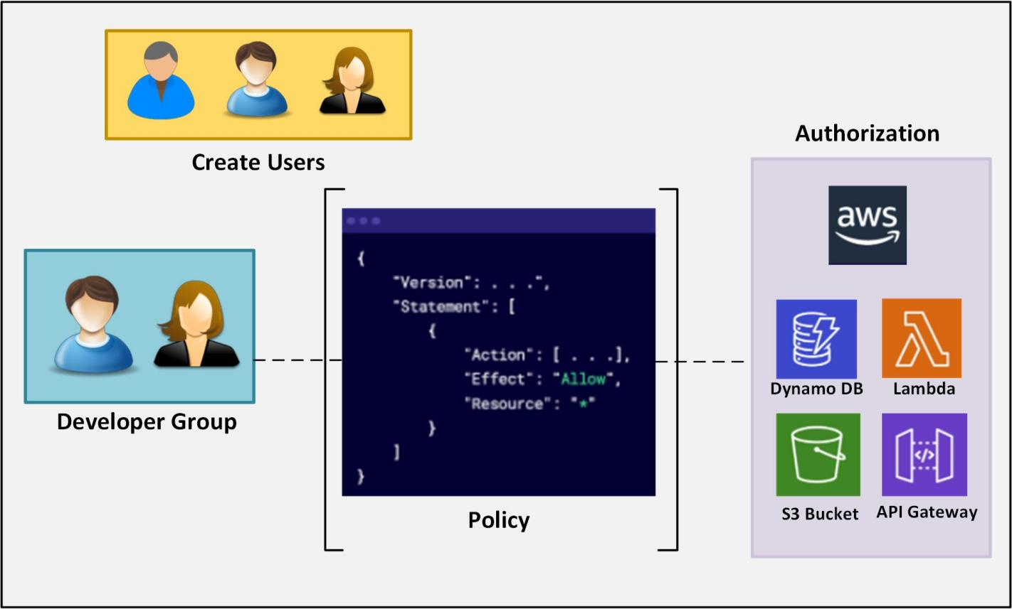

Figure 3-10: Lab Diagram

Implementation Steps

1. Create Users in IAM.
2. Create a Customer-Managed Policy.
3. Create a Group Controlled via a Customer-Managed Policy and Assign Users to a Group.

### Solution

|  |
| --- |
| **Step 1: Create Users in IAM**   1. Log in to the **AWS Console**. 2. Click on **Services**.      1. Scroll down to **Security, Identity & Compliance**. 2. Select **IAM**.      1. Select **Users** when the **Identity and Access Management (IAM)** pane appea**rs**.      1. On the **Users** pane, select **Add users**.      1. On the **Add user** pane, enter the **user name** in the **Set user details** option. 2. Enter **user name** as **developer-1.** 3. Select **Add another user** to add more users.      1. Enter **user name** as **developer-2** and **developer-3**. 2. Select **Password** for **Select** **AWS credential type**. 3. Select **Autogenerated password** for **Console password**. 4. Click on **Next: Permissions**.      1. Leave the remaining settings as **default** and then click on **Next: Review**.      1. Click on **Create users**.      1. The users should be created successfully. 2. Click on the **Close** button.     **Step 2: Create a Customer-Managed Policy**   1. Navigate to **IAM**. 2. In **IAM** Resources, click **Policies** to create a new policy with developer access.      1. Click on **Create Policy**.      1. On the **Create policy** page, click the **Visual editor** tab. 2. For **Service,** click **Choose a service**.      1. In the search field, search for **dynamoDB**, then click on **DynamoDB**. 2. For **Actions,** select **All DynamoDB** **actions (dynamodb:*)** found under **Manual actions**. 3. For **Resources,** select **All resources**. 4. Click **Add additional permissions**.      1. For **Service,** click **Choose a service**. 2. In the search field, search for **lambda**, then click on **Lambda**. 3. For **Actions,** select **All Lambda actions (lambda:*)** found under **Manual actions**. 4. For **Resources,** select **All resources**. 5. Click **Add additional permissions**.      1. For **Service,** click **Choose a service**. 2. In the search field, search for **s3,** then click on **S3**. 3. For **Actions,** select **All S3 actions (s3:*)** found under **Manual actions**. 4. For **Resources,** select **All resources**. 5. Click **Add additional permissions**.      1. For **Service,** click **Choose a service**. 2. In the search field, search for **api,** then click on **API Gateway**. 3. For **Actions,** select **All API Gateway actions (apigateway:*)** found under **Manual actions**. 4. For **Resources,** select **All resources**. 5. Click **Next: Tags** at the bottom of the **page**.      1. Click **Next: Review**.      1. Name the policy, **onlineretailerstore-dev-developergroup-fullaccess-iam-policy**. 2. Click **Create policy**.     **Step 3: Create a Group Controlled via a Customer-Managed Policy and Assign Users to a Group**   1. From the left dashboard menu, select **User groups**.      1. Click **Create group**.      1. Enter the User group name **Developers**. 2. In the Add users to the group - Optional section, select the following **User name**:  * developer-1 * developer-2 * developer-3      1. In the **Attach permissions policies- Optional** section, select the policy we just created, **onlineretailerstore-dev-developergroup-fullaccess-iam-policy.** 2. Click **Create group.**      1. The **Developers user group** will be created. |